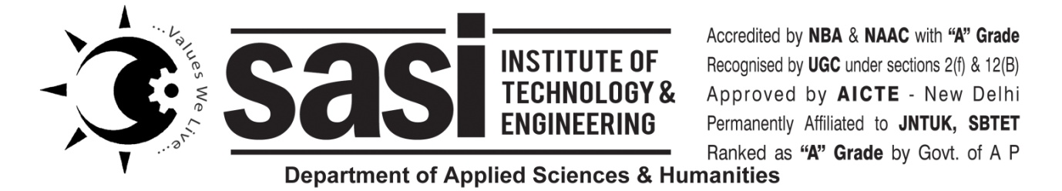

Date 16-7-24

From

K Prasanna Rani,

C-Programming Lab Incharge,

Sasi Institute Of Technology And Engineering.

To

Head Of The Department,

Sasi Institute Of Technology And Engineering,

Tadepalligudem.

Sub: For Maintenance Of C-Programming Lab…..

Respeted Sir,

I Would like to inform you about the maintenance of computer Sytems, Ceiling Fan and Light in c-programming lab.

1.In c-programming lab fan and light not working.

In every section 66 students are attending the computer lab but 60 systems are availabe.

|  |  |  |  |  |
| --- | --- | --- | --- | --- |
| **S.NO** |  | **Available** | **Not Working** | **Required** |
| 1. | Ceiling fan | 8 | 1 fan is not working | 1 |
| 2. | Ceiling light | 6 | 1 light is not working | 1 |
| 3. | Computer systems | 60 |  | 6 |
| 4. | Student chairs | 61 |  | 6 |
| 5. | Staff chair | 1 |  | 1 |

I request you to kindly consider my request and arrange for an extra computer systems.

Thanking you sir,

Yours sincerely.

K.Prasanna